**Baby Patient Simulator  
Marketanalyses**

Mylo Speijers  
Sima Zuri  
Niels Urgert  
Marc Sutjipto  
Antonios Gkougkoulidis  
Youri Lücker  
  
  
Project S4  
6-2-2022

Preface

In this market analysis report we will analyze and summarize all the relevant information about the current market surrounding baby patient simulators. The report is written in a standard analyses format.

Table of Contents

1. General use
2. Current supply and demand
3. Current prices

General use

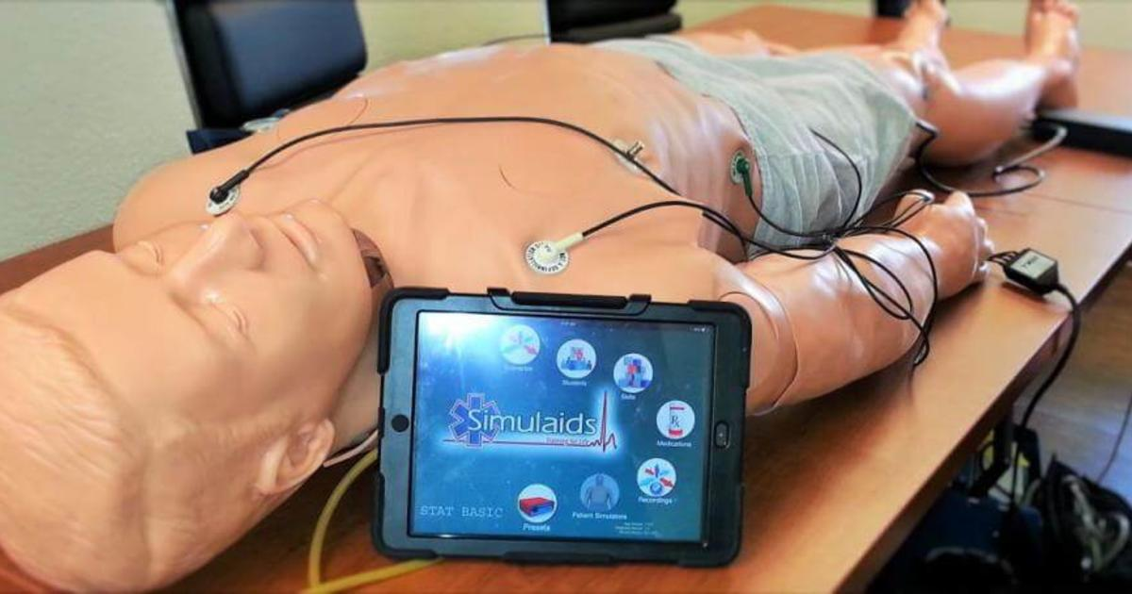Learning how to handle certain medical procedures requires physical practice. Medical students don’t practice on real babies for obvious reasons. Either a baby would have to be put in danger on purpose, or you would have to wait out specific emergencies.   
Physical procedures like this however are not effectively learned from just a textbook.   
That’s why there are numerous ways to simulate this process, either digitally or physically. In this report we will be focusing on the physical simulations.

The specific purpose of a simulation doll varies a lot, dependent on the course. The current market is therefore centered around a lot of options and customization. Models aimed towards high school students are therefore cheaper and simpler than those used by emergency and pediatric teams.

A large Dutch seller for these medical manikins is Verera. Their assortment gives a nice general idea of all the different manikins available:

AED, auscultatie, baby, bloeddruk, bloeding, borstonderzoek, covid trainer, decubitus, diabetes, geboorte, gynaecologie, injectie, katheterisatie, klysma, luchtwegen, prostaat-rectaal, reanimatie, redding training, seksuele educatie, sondevoeding, stomazorg, tracheostoma, verpleegkunde, wondhechting, wondsimulatie & wondverzorging.

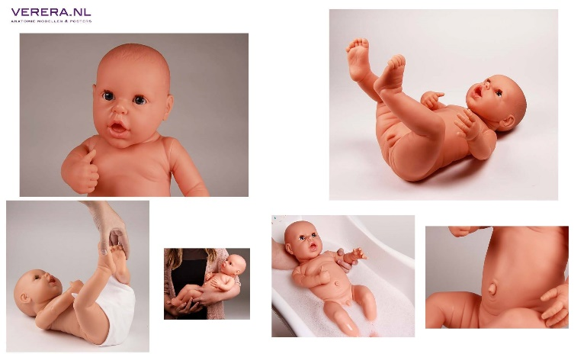Because the current project is centered around infants, most of those options are not relevant for us. However, they can still be used to offer inspiration, while some aspects obviously overlap.

How complicated the manakins are, depends on the use. There’s also regular baby manakins without any organs being simulated. Even those dolls can be useful, for let’s say, practicing diaper changes and such.

Current supply and demand

According to statistics of the CBS, we’ve had a 12% increase in HBO (Higher Vocational Education) nursing students. The amount of MBO (Middle-level vocational education) students perusing a nursing related study stayed roughly the same. Together they form an accumulated 19.1 thousand new students this year.   
The total amount of students following care related training is currently around 72.1 thousand, according to the CBS.   
  
The average person remembers a standard BLS training for about three months, after which it's ideal to take a refresher course. A standard course takes four hours, with a maximum of six students. Because of the large number of courses held, the amount on sales is mostly limited by the current prices for most of those dolls, being mostly well over 1,000, - euro’s.   
Parts like the airway systems need to be interchangeable as well, for hygiene reasons, ranging from 50 cents to 4 euros per product.

**Can’t seem to find current amount of manakins being in use or being sold, have asked Johan for a good source to find information like this!**

**I’ve also contacted head purchasing manager of the HAN, who will try to get me in contact with someone who is familiar with the current amount of manakins at the HAN.**

Questions Johan:

How many models currently in use?  
How long does one manakin last?  
How many parts need to be interchanged ones in a while and how often?  
What is the brand and model of the manakins currently being used by the HAN?